**The Superior University**



**Name:** Faiza Anwar

**Roll No**: 072

**Section**: 4B

**Submitted to:** Sir Raskhi

**N-Queen problem**

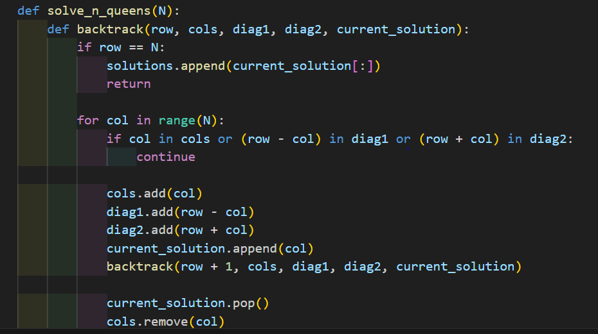

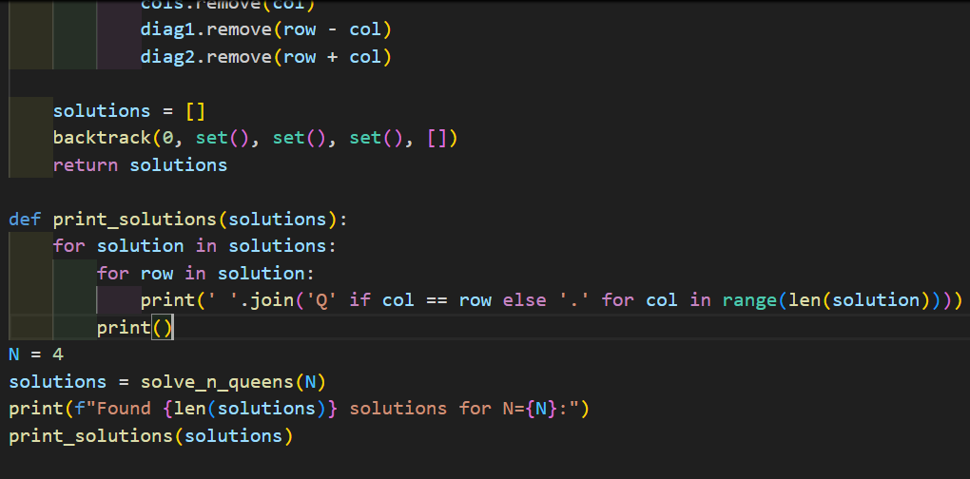

**Output:**

